Quick Reference Guide
How to find your Club’s ID number
September 2017 Version 1

- Log into the Gymnastics Online https://www.gymnastics.org.au/

- Select the link in the top right hand corner Hi, <Your Name>
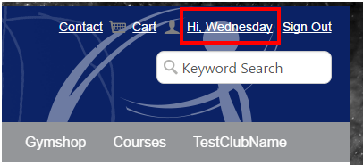
- A new My Account page will appear. Select the Club Admin Home link on the left hand side of the page.
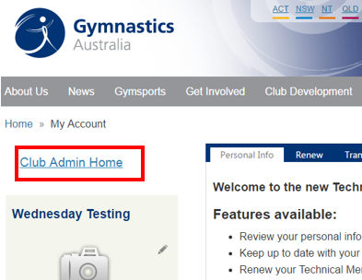
- The Club Administration portal home page will appear.

- Click on the Club Information Tab

- Your Club’s ID number can be found under the Club Information header. Please look at the screenshot on the next page for more information.
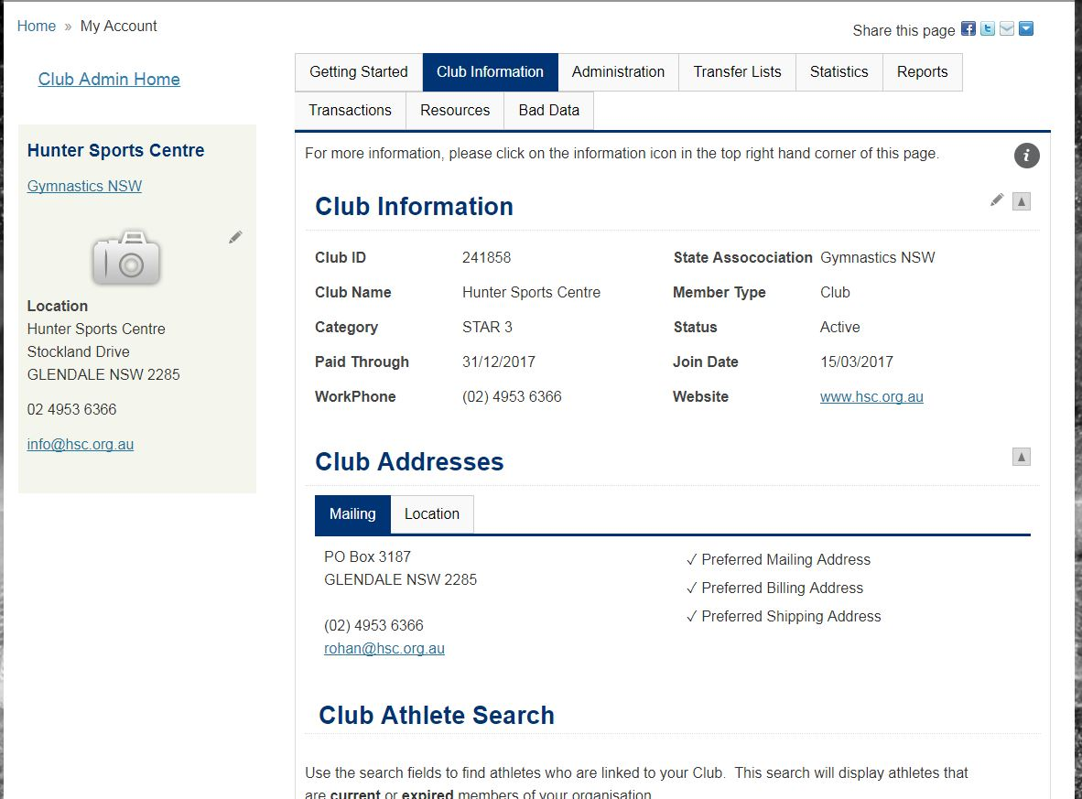

Need more help? Please lodge a support request.

